**EXPERIMENT – 5 : Mark Sheet Processing System**

**PROCEDURE :**

Step – 1: Create a ZOHO account .

Step – 2: Let start creating a new app.

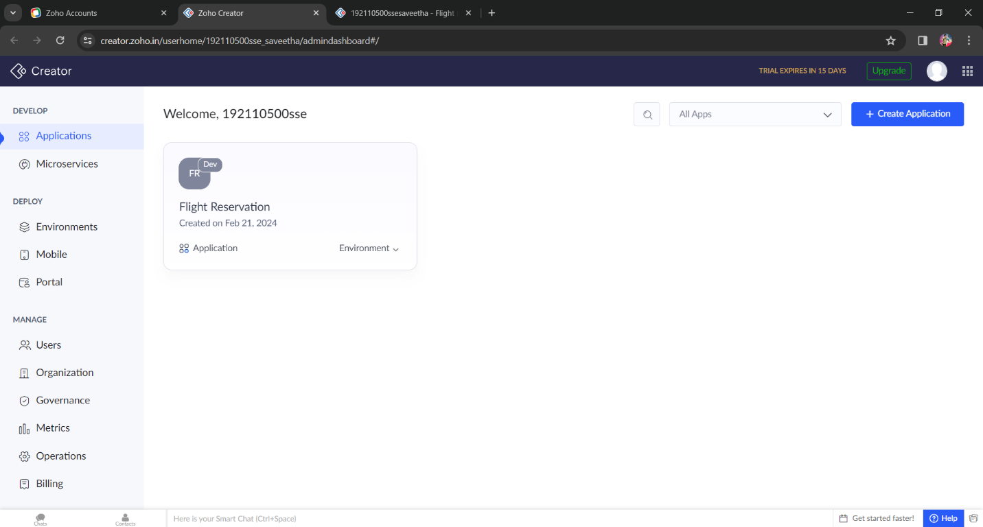

Step – 3: Create new application by selecting the “ + Create Application” option on top right side of the web page.

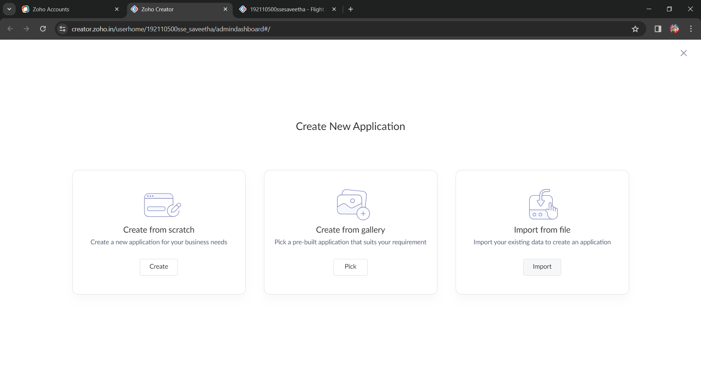

Step – 4: Select any of the three options from the Create New Application page.

Step – 5: Select the “Create from scratch” option among the three options for new creation.

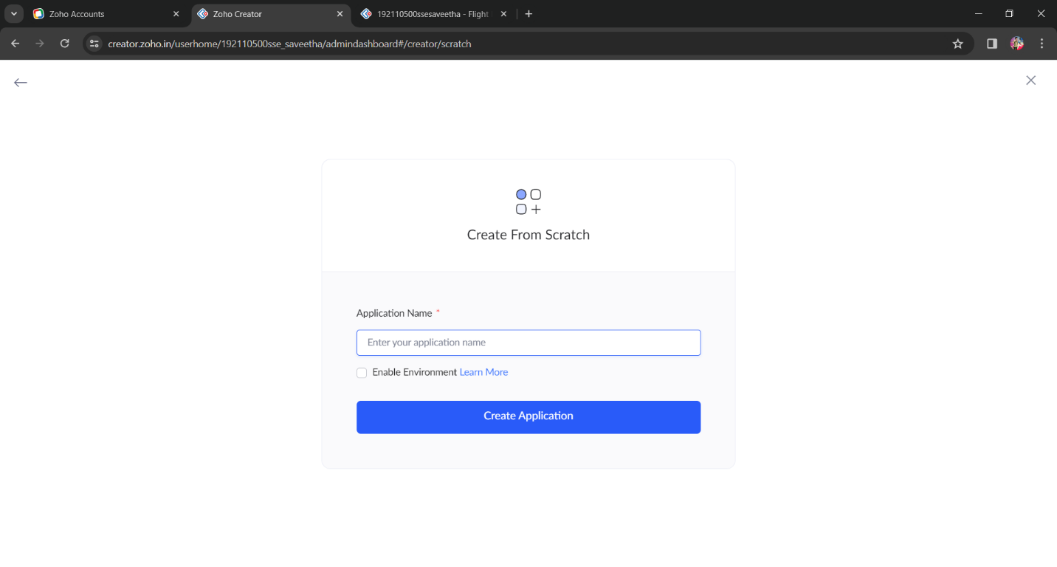

Step – 6: After selecting the scratch option from the options, name the Application Name and after that naming select the option “Enable Environment” and finally choose the option “Create Application”.

Step – 7: Select new form from the web page to create a form.

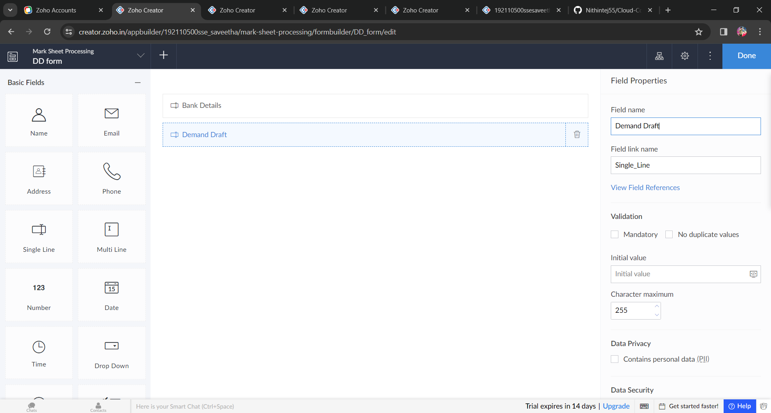

Step – 8: Select any of the option to create a form and we have provided by many of options to choose.

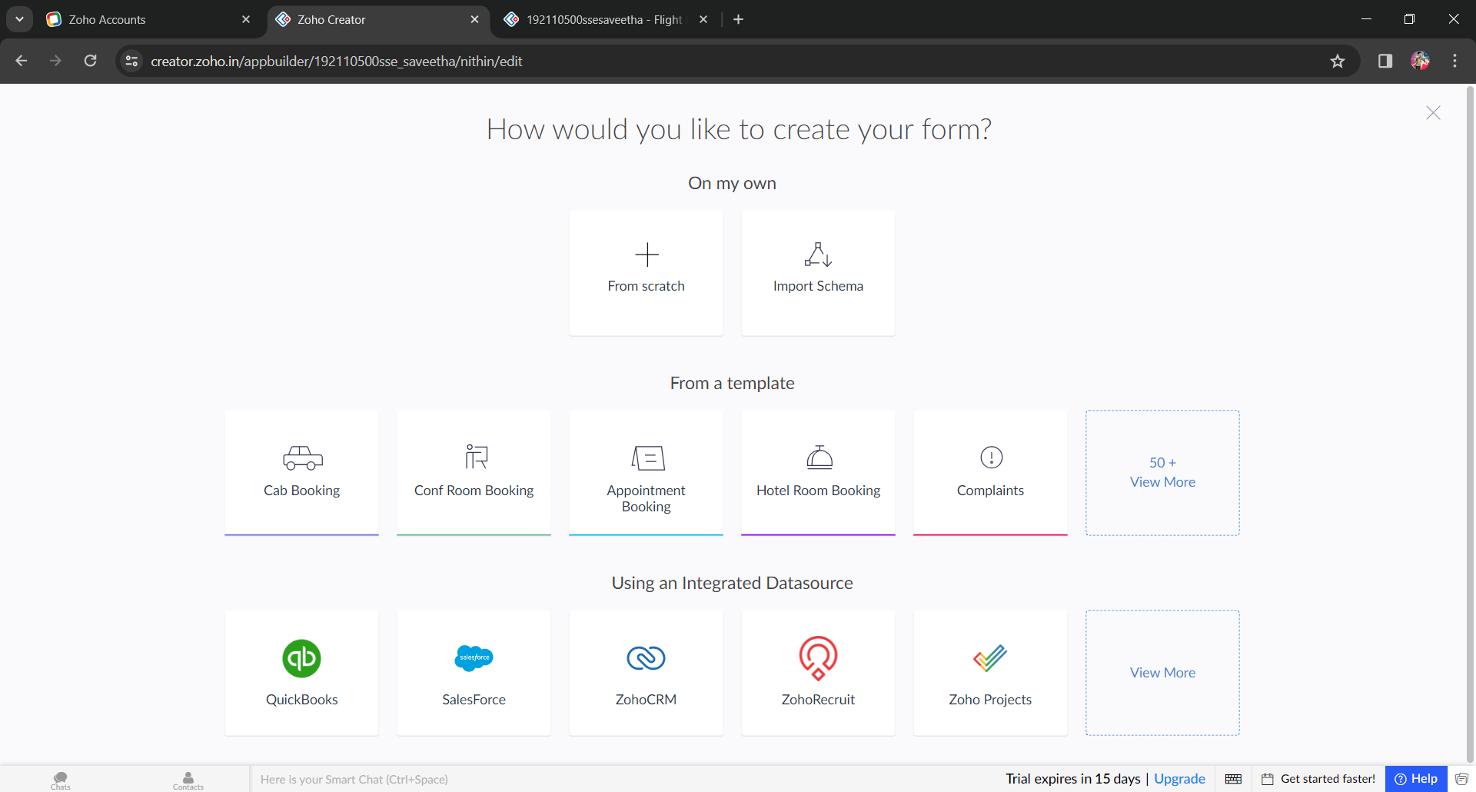

Step – 9: Name a form to create a new form.

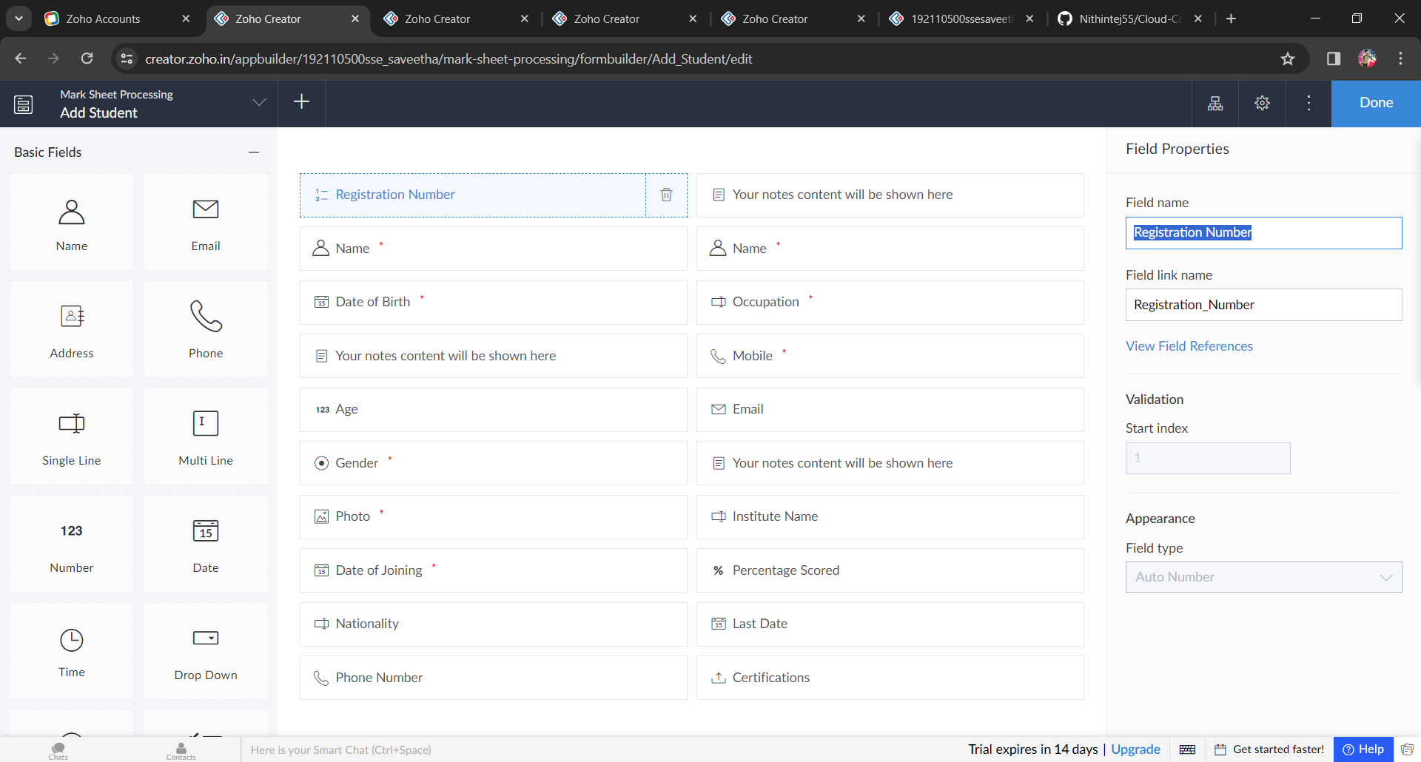

Step – 10: Drag the fields of interest that are necessary for the application to the middle of the web page and after dragging to middle in right side edit option will raise to edit the fields of interest.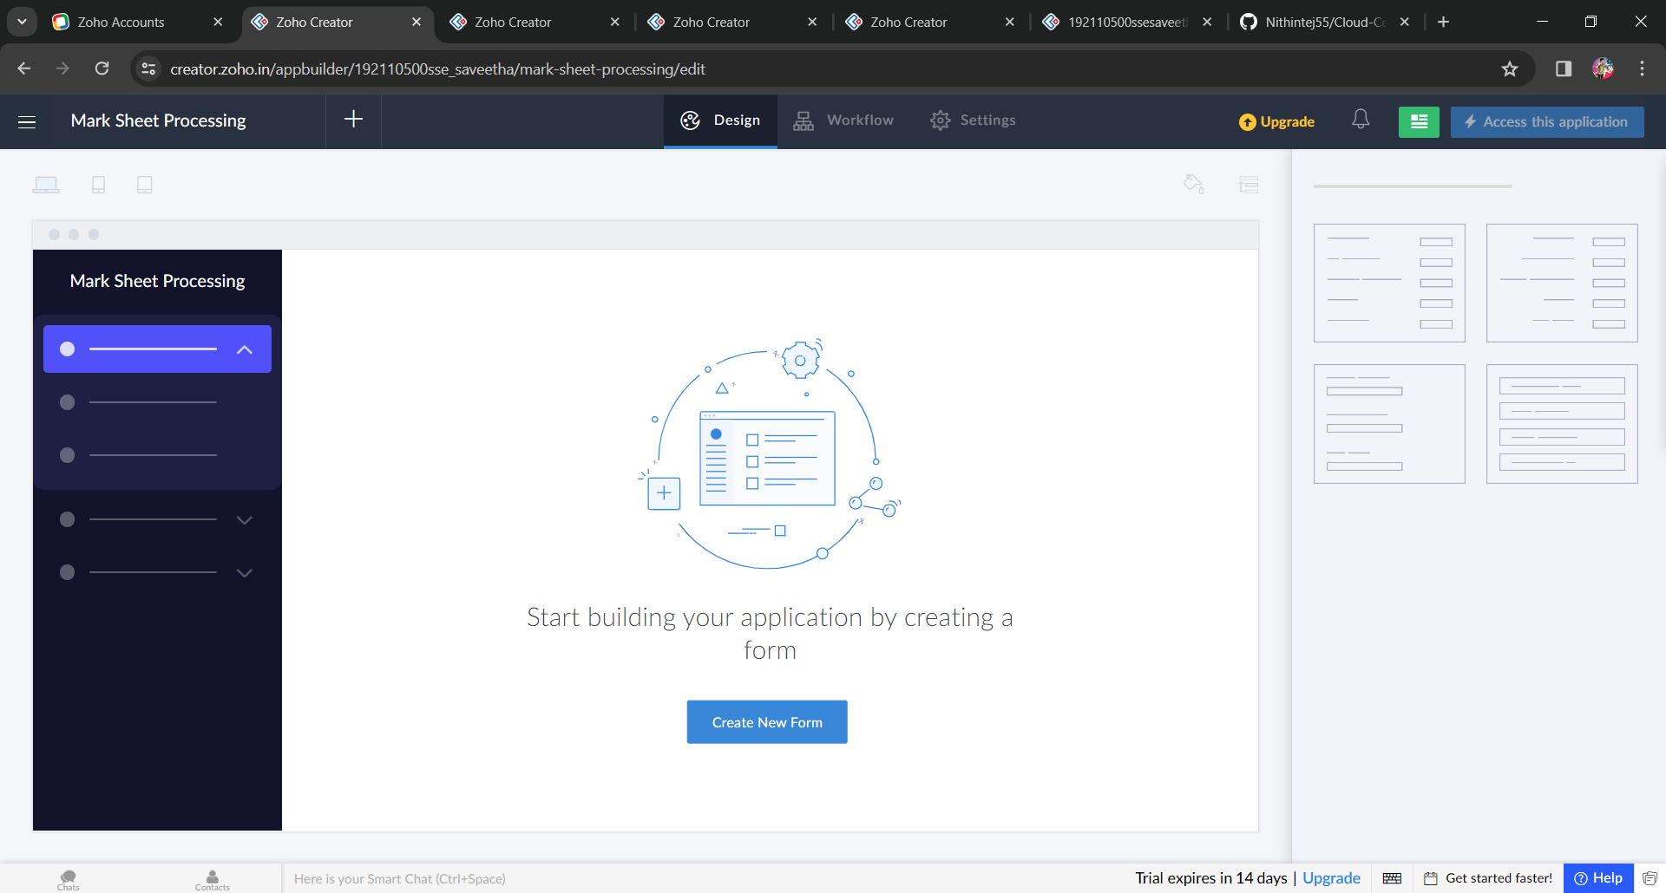

Step – 11: After all creating the needed forms finally select the option “DONE” on the top right side of the w eb page to execute the application.

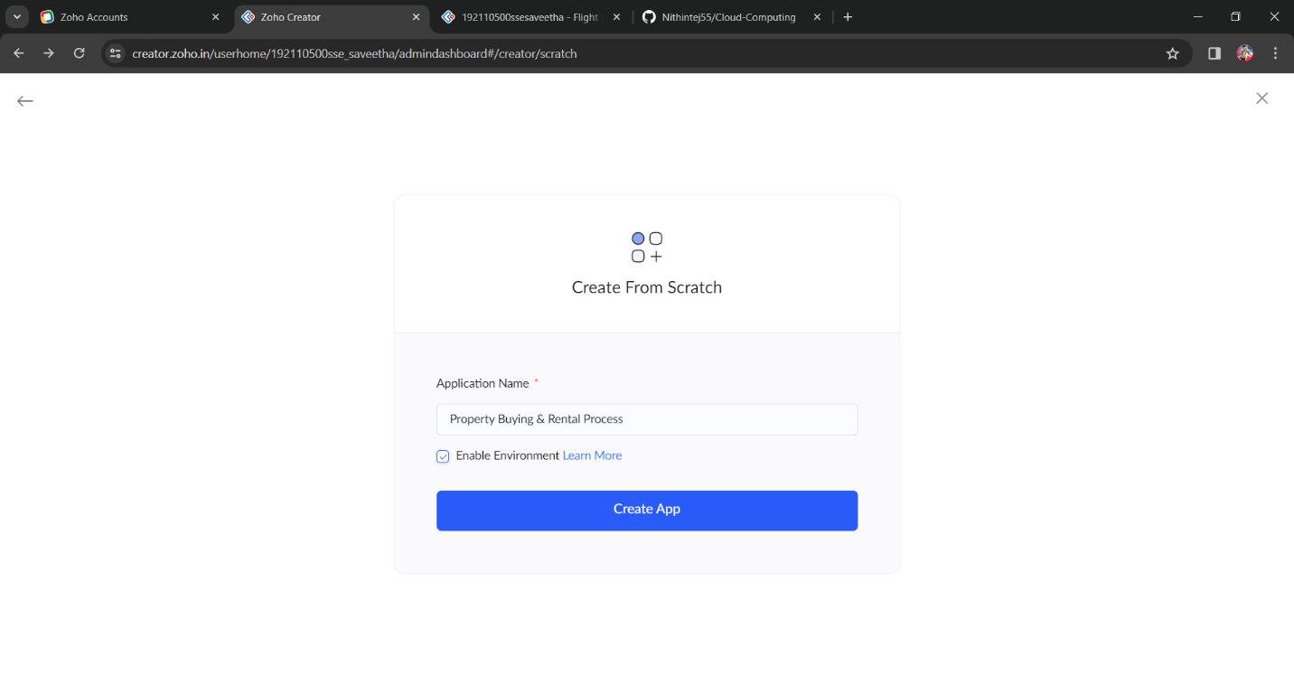

Step – 12: Enter the data that needed to select the travelling in flight, and finally pay the amount to get the flight ticket. And is a option to view the page in a different way like “DESKTOP, MOBILE, TAB” these ate the views to view the web page.

